Brain Tumor Detection Using Convolutional Neural Network

1st Mr. Pradeep Nayak

*Dept of ISE*

*Alva’s Institute of Engineering and Technology* Mangalore, India

[pradeep@aiet.org.in](mailto:pradeep@aiet.org.in)

2nd Koushik Achar

*Dept of ISE*

*Alva’s Institute of Engineering and Technology* Mangalore, India

[koushikachar25@gmail.com](mailto:koushikachar25@gmail.com)

3rd Syed Saleha Dept of ISE

Alva’s Institute of Engineering and Technology Mangalore, India

[4al21is061@gmail.com](mailto:4al21is061@gmail.com)

4th Lohith H 5th Chetan Byahatti

*Dept of ISE Dept of ISE*

*Alva’s Institute of Engineering Alva’s Institute of Engineering and Technology and Technology*

Mangalore, India Mangalore, India [lohithacharya2004@gmail.com](mailto:lohithacharya2004@gmail.com) [chetanbyahatti@gmail.com](mailto:chetanbyahatti@gmail.com)

***Abstract*- *One of the most significant and difficult issues in medical image processing is brain tumor segmentation (BTS) as human classification might cause improper diagnosis and prognosis. Furthermore, when a lot of data needs to be contributed it is an annoying task. It becomes challenging to identify tumor regions in images as brain tumors (BT) exhibit a great level of visual variation as well as mimic healthy tissues. Using the fuzzy C-Means clustering (FCM) approach, we proposed in the current work to exclude brain cancers from the two dimensional MRI. Next came convolutional neural networks (CNNs) and traditional classifiers. Utilizing a real- time dataset which had a diversity of tumor locations, sizes, shapes, image intensities, this experimental study was carried out. Next, we discussed CNNs, which are built with Keras and Tensorflow since they outperform the conventional ones. In this investigation, CNN attained an amazing accuracy rate that is 87.87%. This study's primary objective is to make the differentiation between normal and aberrant pixels utilizing statistical along with texture-based criteria.***

***Keywords—CNN, Medical Image, FCM, SVM, segmentation***

1. INTRODUCTION

A range of non-invasive approaches for looking within the body are called as "medical imaging" [1]. Several image modalities along with procedures are employed in medical imaging to see human body for the diagnostic along with therapeutic purposes. Therefore, it has been essential and required while enhancing individual’s health.

A substantial and essential step that defines the way a higher level of image processing works is picture segmentation [2]. Identifying lesions or else tumors, facilitating efficient machine vision, as well as producing appropriate outcomes for other diagnostics are primary aims of picture segmentation in the medical image procedure. A major concerns in the medical imaging has been improving the sensitivity and specificity of malignancies or lesions utilizing CAD (computer-aided diagnostic) technologies.

As per [3], 34% of men, 36% of women having brain cancer will survive for 5yrs. The tenth leading cause of mortality is cancer of the brain and other neurological systems. Furthermore, the WHO (World Health Organization) reports that 400,000 individuals globally are thought to be impacted with brain tumors, whereas 120,000 individuals have passed away from them in current years [4]. Additionally, 86,970 additional instances of primary brain and other “CNS (Central Nervous System)” tumors, both the malignant and nonmalignant, are anticipated to be found in the US (United States) [5].

A consequence of abnormal cells growing inside the brain is a brain tumor [6]. Malignant, benign tumors are two different categories. BT which are malignant start inside the brain, it spread more rapidly, then quickly disseminate to the surrounding tissues. It might affect additional regions of brain as well as spread to CNS. There are two kinds of malignant tumors: brain metastases, which are secondary tumors that have spread from another place, and primary tumors, that start in brain. The opposite is true for benign brain tumors, which are collections of the cells which grow in brain gradually.

Thus, expanding treatment choices and improving survival rates may depend on early brain tumor detection. However, segmenting tumors or else lesions through hand is a time-consuming, challenging, along with arduous process as numerous MRI images are created during medical treatments. The primary purpose of magnetic resonance imaging, or MRI, is to find cancers or abnormalities in the brain. Since BTS from MRI sometimes requires numerous data, it is a most crucial problem in medical image processing. Furthermore, it's possible that the tumors' soft tissue margins are not distinct. As a result, it is extremely challenging to correctly separate cancers from human brain.

To assist with the segmentation along with identification of brain tumors without a requirement for human interaction, we developed in this paper an advanced and efficient strategy depending on both convolutional neural networks (CNNs) and traditional classifiers.

1. LITERATURE REVIEW

Isolating the “ROI (region of interest)” from an object is a very problematic and demanding task, and separating the tumor from MRI brain imaging requires courage. To produce the best- segmented ROI, worldwide investigators are working in this field to simulate several divergent methodologies from a distinct perspective. These days, segmentation utilizing neural networks yields noteworthy results, and its use is expanding everyday.

.

The spatial FCM technique and mathematical morphological procedures, which minimize computing time, were used by Devkota et al. [7] to design the full segmentation process. Although this suggested solution hasn’t yet undergone review, findings indicate that it has an 82% accuracy rate in detecting cancer and an 86.6% accuracy rate in the classifier. The histogram-based segmentation technique was comparable to the one employed by Yantao et al. [8]. considering the task of segmenting brain tumors as a 3 class classification issue utilizing 2 modalities (FLAIR, T1) (the tumor comprises tumor, edema, normal tissue in addition to necrosis). The aberrant regions were identified utilizing FLAIR modality’s region-based active contour model. The k-means approach, that had a 73.6% dice coefficient as well as 90.3% sensitivity, was utilized to discriminate among tumor along with edema tissues in aberrant regions employing contrast enhancement in the T1 modality.

The ROI was retrieved by Badran et al. [9] utilizing adaptive thresholding in combination with ingenious “edge detection model”, which was founded on edge detection techniques. The dataset included 102 photographs. Two neural network sets were employed after the photos were preprocessed: the 1st set utilised canny edge detection, whereas 2nd set utilized adaptive thresholding. Segmented image has then been given a level number, its distinguishing characteristics have been extracted using Harris approach. 2 neural networks have been subsequently utilized to analyze the brain: one to identify the type of tumor and the other to evaluate if the brain is healthy or tumor-free. The clever edge detection approach generated more appropriate findings when these two models were evaluated and the outcomes were shown. Using tumor development patterns as distinguishing criteria, Pei and colleagues suggested improving longitudinal MRI texture-based tumor segmentation. Label maps have been then utilized to predict cell density and create tumor development models once textures (that include, fractal, mBm) as well as intensity characteristics have been extracted. The model's performance has been evaluated by mean DSC with the tumor cell density, which is “LOO:0.819302”, “3-Folder:0.82122”. Test dataset had 15 individuals, whereas the training dataset included 20 people. Accuracy varies from 73percent to 88percent as per spread value.

With minor morphological adjustments, Rajendran et al. [13] were capable of achieving 85.3percent and 82.1percent of ASM, “Jaccard Index” dependent on “Enhanced Probabilistic Fuzzy C- Means model”, correspondingly, through concentrating on “Region-based Fuzzy Clustering” as well as deformable model. Zahra et al. [14] utilized LinkNet network for tumors segregation. For segmentation, each of the seven training datasets was first sent to a separate Linknet network. Regardless of images’ view point, they created an approach that enables CNN to classify the most frequent kind of brain tumors automatically without requiring any preprocessing. Score of 0.73 has been received by a single network on the dice, whereas several systems receive a score of 0.79.

# PROPOSED METHODOLOGY

Our suggested method uses 2 distinct models for brain tumor diagnosis along with segmentation. While 2nd model emphasizes applying deep learning (DL) to identify tumors, the 1st model utilized FCM to segment the tumor, conventional ML (machine learning) approaches to categorize it. FCM segmentation yields better outcomes for the noisy clustered data sets [15]. Even though it requires longer to execute, more information is retained by it.

1. *Suggested Approach for Classifying and Segmenting Tumors Using Conventional Classifiers*

The classifiers for our model are compared, and our initial prospective model segmented and identified brain tumors utilizing a ML technique. Filtering, skull stripping, along with augmentation, segmentation utilizing the “fuzzy C Means algorithm”, the morphological operations, the “tumor contouring”, the feature extraction, along with classification employing traditional classifiers are 7 processes that comprise our suggested brain image segmentation method. We were pleased with the results of our work. Key stages of this suggested model will be shown in sections that follow (Figure 1).

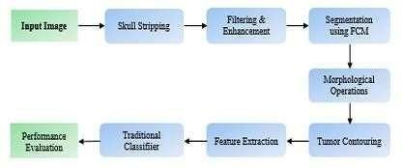

Fig. 1. Proposed methodology for classification utilizing Traditional Classifiers

1. Skull Stripping: This has been a crucial stage in medical image procedure since MRI image's background is useless and just increases processing time. In this investigation, skull part of MRI images was extracted in 3 steps. The 3 steps are as subsequent:
   1. Otsu Thresholding: For eliminating the skull, Otsu's Thresholding method has been utilized by us, that automatically establishes threshold value as well as separates the image into foreground, background. Intra-class variance, or the weighted sum of the deviations of the 2 classes, is minimized by the threshold utilized in this procedure.
   2. Connected Component Analysis: After utilizing this approach to isolate just brain area, we removed skull section as the final stage in our skull stripping process.

Utilizing this analysis to isolate only the brain area.

1. Filtering and Enhancement: Since brain MRI images have been more inclined to contain noise in contrast with slightly different form of medical imaging, we must optimize MRI image quality whereas minimizing noise for better segmentation. To diminish Gaussian noise in brain MRI, we utilized a Gaussian blur filter in this work to enhance segmentation performance.
2. Segmentation with FCM: The FCM technique, that lets one piece of data belong to two or more groups, was used for segmentation. We were able to ensure better segmentation at this step by obtaining the fuzzy clustered segmented image.
3. Morphological Operation: In this research, we only require the brain, not skull, for tumor segmentation. This was accomplished by applying morphological approaches to our images. At first, the poorly connected regions of MRI imagine had been separated utilizing erosion. After the erosion, our images will display variety of fragmented regions. Then dilation had been utilized.
4. Tumor Contouring: To eliminate tumor clusters, an intensity- based technique called thresholding was applied. The output of the photograph is the area of tumor that has been emphasized against a black background.
5. Feature Extaction: For the classification, 2 categories of attributes had been eliminated. The segmented MRI images had been utilized to extract texture-based qualities for example dissimilarity, correlation, energy, homogeneity, and ASM, whereas statistical-based variables that include centroid, mean, skewness, standard deviation, entropy, kurtosis.
6. Conventional Classifiers: We employed 6 conventional ML classifiers that include, “NB (Naïve Bayes)”, “LR (Logistic Regression)”, “MLP (Multilayer Perceptron)”, “KNN (K-Nearest Neighbor)”, “SVM (Support Vector Machine)”, and “RF (Random Forest)” for assessing the tumor detection accuracy of this suggested model.
7. Evaluation Stage: Our model most consistently splits ROI along with isolating the tumor portion when compared to other region- based segmentation techniques. Complete process has been illustrated in Fig. 5. We employed 6 classification approaches after segmenting, extracting features from tumor. With an accuracy of 82.42%, SVM provided the greatest result of all.
8. *Proposed Methodology Using CNN*

Medical image processing makes extensive use of CNNs. Over the years, various investigations have tried to create a model which may detect malignancies with greater accuracy. We tried to create an example that might precisely recognize tumor from two- dimensional MRI images of brain. Though a fully connected (FC) neural network might be used for detecting the tumor, we choose to use CNN for this model related to its parameter sharing along with connection sparsity.

A five-layer CNN has been introduced, implemented for detecting cancers. The aggregated model, that includes 7 stages and hidden layers, offers most noteworthy result for the tumor's diagnosis. Here is a summary of the recommended method.

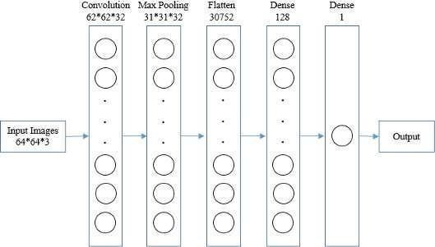

Fig. 2. The Proposed Methodology for the tumor detection utilizing 5-Layer Convolutional Neural Network

Utilizing the “convolutional layer” as beginning layer, MRI images have been transformed into a homogeneous dimension through creating an input shape of 64*64*3. After assembling each image in the similar feature, we formed “convolutional kernel” that was convoluted with input layer. With the help of three channel tensors, it employs 32 3*3 convolutional filters. As an activation function, ReLU has been utilized to stop output from being corroborated.

Reduce the network's computation time and parameter chunk by gradually shrinking the representation's spatial dimension in this ConvNet design. Furthermore, altering brain MRI images might lead to overfitting contamination; in this situation, the Max Pooling layer is most suited for this viewpoint. In order to supplement our input image with spatial data, we utilized MaxPooling2D for this model. 31*31*32 are the dimensions of this convolutional layer. “Pool size is (2, 2)”, tuple of 2 numbers that may be utilized for both vertical and horizontal downscaling, when input images are split in both the spatial dimensions.

A “pooled feature map” has been generated succeeding pooling layer. A most essential layer after pooling is the flattening, that is required for processing because the images being processed must be converted into single column vector. It has been subsequently sent to neural network for processing.

They used 2 FC layers. Dense-1, Dense-2 were the dense layer's representations. Once neural network has been processed utilizing Keras' dense function, resultant vector has been employed as an input for this layer. 128 nodes make up the hidden layer. We kept number of dimensions or else nodes as low as feasible because it is correlated with the amount of processing power needed to fit in this model; from this angle, 128 nodes yield the most substantial findings. Remarkable convergence performance of ReLU renders it the preferred activation function.

2nd was FC layer had been this model’s final layer, following initial dense layer. In this layer, where there is only one node overall, we employed sigmoid function as activation function as we need to utilise less computing resources to ensure a longer execution time. Even though there is a risk that utilizing the sigmoid as activation function would impede learning in deep networks, for this deep network, the number of nodes is much fewer and easier to manage when we scale the sigmoid function. Finally, Fig.3 shows the workflow of this suggested CNN model.

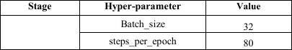

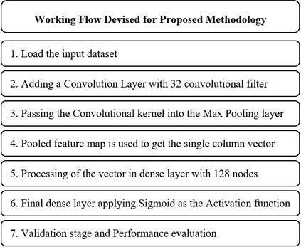Fig. 3. Working flow of the proposed CNN Model.

For determining the accurateness of tumor detection, we constructed this model employing “ Adam optimizer” along with binary cross-entropy as a loss function. Model's performance has been assessed by us utilizing an approach shown in Fig.4.

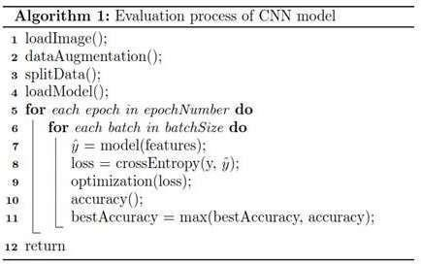

Fig. 4. The Algorithm of the performance evaluation

Values for each hyper-parameter have been listed in the Table I. The achieved accuracy is approximately 87.87percent.

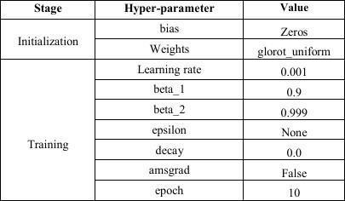TABLE I. T H E HYPERPARAMETER VALUE OF CNN MODEL

1. EXPERIMENTAL RESULTS

Fig. 5 compares our suggested ML and DL classification models and procedures for tumor segmentation from two dimensional brain MRI for supporting this model. While CNN achieved an accuracy of 87.87%, SVM provided an 82.42% accuracy.

1. *Experimental Dataset*

The BRATS dataset [16] been utilized by us, an established standard in field of the segmentation of brain tumor, to estimate the efficacy of this proposed method. It has been split into 2 groups, class-0 and class-1, that signifies non-tumor, tumor MRI images, correspondingly. Class-0 and class-1 had been allocated to 30 and

187 MRI pictures with non-tumor and tumor, correspondingly. Images are all MRI images captured utilizing distinct modalities, that include FLAIR, T1, and T2. By dividing the dataset 70 by 30, we were able to get the greatest results for traditional ML classifiers when it came to training the testing images. We separated CNN dataset into 70-30 and 80-20 forms, then made the comparison of the findings.

1. *Segmentation utilizing Image processing techniques* Utilizing our suggested techniques, we were able to segment the tumor without losing any significant information. Skull has been removed by us since its role in tumor segmentation is basically ambiguous and nil.

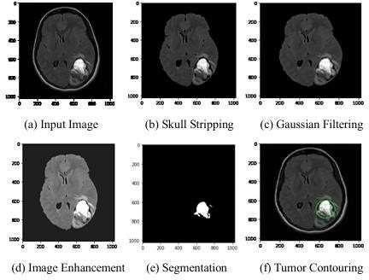

Fig. 5. Segmentation processes of an MRI

An input image was a 2D MRI that had been taken out of this dataset. Input picture was processed utilizing skull stripping method (Fig. 1b) as well as image augmentation (Fig. 1c) to better understand features of MRI. After removing noise with the “Gaussian filter” (Fig. 1d), “FCM segmentation” approach is simulated (Fig. 1e), finally, “tumor contouring” (Fig. 1f) is performed to identify ROI that represents tumor for brain MRI.

After tumor had been segmented, we classified it utilizing a distinct of traditional ML methods.

|  |  |  |  |  |  |  |
| --- | --- | --- | --- | --- | --- | --- |
| **Classifie rs** | **Accurac y** | **Recall** | **Specific ity** | **Precision** | **Dice Score** | **Jaccard Index** |
| KNN | 79.39 | 0.949 | 0.428 | 0.933 | 0.  941 | 0.889 |
| LR | 83.88 | 0.949 | 0.286 | 0.918 | 0.933 | 0.875 |
| Multila yer  Percepti on | 84.39 | **1.000** | 0 | 0.894 | 0.944 | 0.894 |
| NB | 78.79 | 0.797 | **0.714** | **0.959** | 0.870 | 0.770 |
| RF | 86.39 | 0.983 | 0.167 | 0.903 | 0.943 | 0.892 |
| **SVM** | **87.42** | 0.983 | 0.428 | 0.935 | **0.959** | **0.921** |

TABLEII. Extracted Featuresfrom segmentedtumor

|  |  |  |  |  |  |  |  |
| --- | --- | --- | --- | --- | --- | --- | --- |
| **Imag**  **e N**  **o** | **Contr a**  **st** | **Dissimi l**  **arity** | **Homoge n**  **eity** | **Energy** | **Correlat i**  **on** | **ASM** | **Lab**  **el** |
| 1 | 281.18 | 1.37 | 0.97 | 0.90 | 0.97 | 0.81 | 1 |
| 2 | 97.36 | 0.53 | 0.98 | 0.98 | 0.94 | 0.96 | 1 |
| 3 | 337.39 | 1.68 | 0.98 | 0.97 | 0.82 | 0.95 | 1 |
| 4 | 357.59 | 2.34 | 0.94 | 0.92 | 0.90 | 0.86 | 1 |
| 5 | 149.37 | 0.82 | 0.98 | 0.96 | 0.96 | 0.93 | 0 |
| 6 | 357.59 | 2.34 | 0.95 | 0.93 | 0.90 | 0.86 | 0 |

With an accuracy of 87.42%, SVM yields the most noteworthy result among the six traditional ML classifiers, as shown in Table III. When considering the other performance metrics, the difference between SVM and NB was minuscule and inconsequential, despite the latter producing noteworthy findings regarding Precision and Specificity. From further performance metrics, we also concluded that SVM yielded the greatest findings regarding recall, precision, Jaccard Index, dice score, and so on.

1. *Classification Using Machine Learning*

The most popular methods for figuring out the ROI are texture and statistically based features. These features permit us to distinguish among tumorous along with non-tumorous MRIs. For the classification, statistically based characteristics as well as texture have been utilized by us. The segmented brain tumor was employed to extract statistical data (mean, skewness, entropy, standard deviation, centroid, kurtosis) along with texture-based characteristics (energy, difference, correlation, homogeneity, ASM). We additionally determine tumor's diameter, size, and convex hull area. We were able to classify the image into normal as well as disease tissue by generalizing such characteristics from segmented MRI.

Table II displays values of a few segmented MRIs' features. Classification was finished after feature extraction. SVM, RF, NB, KNN, LR, and Multilayer Perception were the six classifiers that we employed. The accuracy was highest using SVM. The performance of the classifiers and the confusion measures have been illustrated in Table III. Subsequent factor is used to evaluate the performance:

*Accuracy*=TP +TN/TP+FP+TN+FN (i)

𝑆𝑒𝑛𝑠𝑖𝑡𝑖𝑣𝑖𝑡𝑦(𝑟𝑒𝑐𝑎𝑙𝑙)= TP/TP+FN (ii)

*Speficity*=TN /TN +FP (iii)

𝑃𝑟𝑒𝑐𝑖𝑠𝑖𝑜𝑛 (𝑃𝑃𝑉)=TP/TP+FP (iv)

TABLE III. Confusion Metrics’ofthe Classifiers

Outcome when 80:20 is the divide. Performance of the suggested CNN-based technique has been shown in Table IV.

Even though we employed a five-layer CNN, our accuracy of 87.87% is outstanding. When using this CNN model with five layers, the variations in the findings were not very noticeable, even though we performed evaluations with different numbers of layers. We ran into problems with computation speed, batch size complexity, and incredibly high steps per method as we raised the number of layers. Furthermore, we put the dropout amount to 0.2, but the accuracy flattened, therefore we did not modify the model correspondingly. As a consequence, without dropout, the maximum accurateness has been provided by this model.

TABLE IV. Performance of the Proposed CNNM

|  |  |  |  |  |
| --- | --- | --- | --- | --- |
|  | **Training Image** | **Testing Image** | **Splitting Ratio** | **Accuracy (%)** |
| i | 152 | 65 | 70:30 | 82.98 |
| ii | 174 | 43 | 80:20 | **87.87** |

Accurateness of this model's training and validation is shown in Fig. 6. The Keras callbacks method had been employed for computing it. We examined the accuracy of training and validation employing varying numbers of epochs. We revealed that model reaches its peak accuracy for both training along with validation after nine epochs.

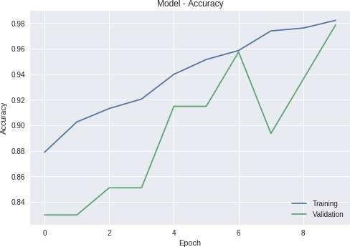

Fig. 6. Accuracy of the proposed CNN model

*E. Performance Comparison*

Lastly, we contrasted CNN with our suggested classification techniques, utilizing conventional ML classifiers. Furthermore, We evaluated our outcomes with those of a few other investigations that employed similar datasets. Investigators in Seetha et al. [17] used CNN to obtain 87.5% accuracy and SVM-based classification to reach 83.0% accuracy. Our proposed method outperformed both ML and CNN based classification. Our dice score is 86%, while Mariam et al. [18] achieved a die coefficient of nearly 85%.

TABLE V. Performance Comparison

|  |  |
| --- | --- |
| **Methodology** | **Accuracy (%)** |
| “Seetha et al [17]” | 87.5 |
| **“Proposed CNN Model”** | **87.87** |

Conclusion and FutureWork

Due to various medical images, the image segmentation has been significant in medical image processing. We segmented brain tumors using MRI and CT scan pictures. Brain tumor classification and segmentation are the two most popular uses of MRI. FCM, that may precisely predict tumor cells, had been utilized in this investigation for tumor segmentation. Following the segmentation stage, classification was done using both conventional classifiers along with CNNs. The findings of numerous traditional classifiers, that include KNN, LR, MLP, NB, RF, and SVM, were utilized and contrasted in conventional classifier section. The SVM yielded the 82.42percent highest accuracy among these conventional models.

We furthermore employed CNN to improve the findings, and it produced an accuracy of 87.87percent with an 80:20 split ratio of 217 shots, that means that 20percent of the images had been used for testing and 80% of the images were training. In future, we believe we can more effectively segregate brain tumors utilizing 3D brain imaging. Since employing larger dataset can be even more difficult in this regard, we aim to develop a dataset which emphasize the abstract regarding our nation to widen the our work' scope more quickly.

# References

1. Kasban, Hany & El-bendary, Mohsen & Salama, Dina. (2015). “A Comparative Study of Medical Imaging Techniques”. International Journal of Information Science and Intelligent System. 4. 37-58.J. Clerk Maxwell, A Treatise on Electricity and Magnetism, 3rd ed., vol. 2. Oxford: Clarendon, 1892, pp.68–73.
2. D. Surya Prabha and J. Satheesh Kumar, “Performance Evaluation of Image Segmentation using Objective Methods”, Indian Journal of Science and Technology, Vol 9(8), February 2016.
3. Brain Tumor: Statistics, Cancer.Net Editorial Board, 11/2017 (Accessed on 17th January 2019)
4. Kavitha Angamuthu Rajasekaran and Chellamuthu Chinna Gounder, Advanced Brain Tumour Segmentation from MRI Images, 2018.
5. General Information About Adult Brain Tumors". NCI. 14

April 2014. Archived from the original on 5 July 2014. Retrieved 8 June 2014. (Accessed on 11th January 2019)

1. M. Young, The Technical Writer’s Handbook. Mill Valley, CA: University Science, 1989.
2. B. Devkota, Abeer Alsadoon, P.W.C. Prasad, A. K. Singh, A. Elchouemi, “Image Segmentation for Early Stage Brain Tumor Detection using Mathematical Morphological Reconstruction,” 6th International Conference on Smart Computing and Communications, ICSCC 2017, 7 8 December 2017, Kurukshetra, India.
3. Song, Yantao & Ji, Zexuan & Sun, Quansen & Yuhui, Zheng. (2016). “A Novel Brain Tumor Segmentation from Multi- Modality MRI via A Level Set-Based Model”. Journal of Signal Processing Systems. 87. 10.1007/s11265-016-1188-4.
4. Ehab F. Badran, Esraa Galal Mahmoud, Nadder Hamdy, “An Algorithm for Detecting Brain Tumors in MRI Images”, 7th International Conference on Cloud Computing, Data Science & Engineering - Confluence, 2017.
5. Pei L, Reza SMS, Li W, Davatzikos C, Iftekharuddin KM. “Improved brain tumor segmentation by utilizing tumor growth model in longitudinal brain MRI”. Proc SPIE Int Soc Opt Eng. 2017.
6. Dina Aboul Dahab, Samy S. A. Ghoniemy, Gamal M. Selim, “Automated Brain Tumor Detection and Identification using Image Processing and Probabilistic Neural Network Techniques”, IJIPVC, Vol. 1, No. 2, pp. 1 8, 2012.
7. Mohd Fauzi Othman, Mohd Ariffanan and Mohd Basri, “Probabilistic Neural Network for Brain Tumor Classification”, 2nd International Conference on Intelligent Systems, Modelling and Simulation, 2011.
8. A. Rajendran, R. Dhanasekaran, “Fuzzy Clustering and Deformable Model for Tumor Segmentation on MRI Brain Image: A Combined Approach,” International Conference on Communication Technology and System Design 2011.
9. Sobhaninia, Zahra & Rezaei, Safiyeh & Noroozi, Alireza & Ahmadi, Mehdi & Zarrabi, Hamidreza & Karimi, Nader & Emami, Ali & Samavi, Shadrokh. (2018). “Brain Tumor Segmentation Using Deep Learning by Type Specific Sorting of Images”.
10. Gupta, Gaurav and Vinay Singh. “Brain Tumor segmentation and classification using Fcm and support vector machine.” (2017).
11. Anam Mustaqeem, Ali Javed, Tehseen Fatima, “An Efficient Brain Tumor Detection Algorithm Using Watershed & Thresholding Based Segmentation”, I.J. Image, Graphics and Signal Processing, 2012, 10, 34 39.
12. Seetha, J & Selvakumar Raja, S. (2018). “Brain Tumor Classification Using Convolutional Neural Networks. Biomedical and Pharmacology Journal”. 11. 1457-1461. 10.13005/bpj/1511.
13. Mariam Saii, Zaid Kraitem, “Automatic Brain tumor detection in MRI using image processing techniques”, Biomedical Statistics and Informatics, Vol. 2, No. 2, pp. 73-76, 2017.